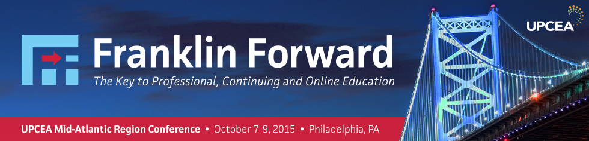

**Exhibitor Handbook**

Thank you for supporting the UPCEA Mid-Atlantic Regional Conference in Philadelphia! We are looking forward to an engaging and innovative event. The following pages include helpful information to make your experience as an exhibitor a great one. If you have any questions or need further assistance, please contact me via e-mail at [porourke@upcea.edu](mailto:porourke@upcea.edu) or via telephone: 202.400.2684

Best wishes,

Patrick O’Rourke

Associate Director, Membership and Corporate Engagement

UPCEA – Leaders in Professional, Continuing, and Online Education

**Location**

DoubleTree by Hilton Philadelphia Center City

237 S Broad St

Philadelphia, PA 19107

UPCEA has secured a discounted rate of $179 per night for UPCEA attendees.

The deadline for this discount is September 6, 2015. To reserve your room [click here](https://aws.passkey.com/event/13030114/owner/4129/home).

**Exhibit Space**

To ensure you have the maximum opportunity to connect with conference attendees, the exhibitor area for the 2015 UPCEA Mid-Atlantic Regional Conference will be in the Overture, directly outside of the general and concurrent session rooms.

Arrangement of Exhibits

UPCEA will provide one (1) 6 foot draped table and one chair, which will be supplied by the hotel.

Height Limitation for Displays

Exhibitors shall not display or place any product, sign, partition, person, apparatus, shelving or other construction that extends the size of the table, 72” x 30”. Height is not to exceed more than 48 inches from the table top/8 feet from the floor. Free standing displays may be placed behind the tabletop ONLY and must pertain to the height restrictions.

**Exhibit Hall Hours**

**Please note the follow Exhibit Hall hours. For the complete conference schedule,** [**click here**](http://conferences.upcea.edu/mid-atlantic/schedule.html)**.**

**WEDNESDAY, October 7**

8:00–11:30 a.m. Exhibitor Setup

12:00–6:00 p.m. Exhibit Hall Open

**THURSDAY, October 8**

7:30 a.m.–5:00 p.m. Exhibit Hall Open

**FRIDAY, October 9**

7:30–10:30 a.m. Exhibit Hall Open

10:30 a.m.–1:00 p.m. Exhibit Hall Dismantle

**Important Deadlines**

Company Logo

* The UPCEA Mid-Atlantic Region values your support of its 2015 regional conference. To promote your logo on the conference website, mobile app, and program, please submit your [logo via the wufoo form](https://upcea.wufoo.com/forms/midatlantic-2015-regional-conference-exhibit/) by **September 11, 2015**.

Exhibit Booth Representative

* If you have not already done so, [please click here](https://upcea.wufoo.com/forms/midatlantic-2015-regional-conference-exhibit/) to provide the name of your booth representative by **September 11, 2015**.

**Note:** Tabletops include one full conference registration. Additional registrations can be purchased at the corporate member or non-member attendee registration rate [via the conference website](http://conferences.upcea.edu/mid-atlantic/registration.html).

Bag Stuffing Items

The UPCEA Mid-Atlantic Region would like to extend the opportunity for you to provide one item to be included in the conference attendee bag. **If you would like to take advantage of this opportunity, items must be received no later than October 5, 2015, and be addressed to:**

UPCEA Mid-Atlantic Bag Stuffing

DoubleTree by Hilton Philadelphia Center City

237 S Broad St

Philadelphia, PA 19107

**Shipments**

Exhibitors wanting to ship items in advance to the University of Delaware may do so by shipping to the facility directly. **To ensure that your package arrives in time, please schedule your shipment to arrive no later than Monday, October 6, 2014, at the following address:**

DoubleTree by Hilton Philadelphia Center City

UPCEA Mid-Atlantic Conference (Vendor name and cell phone)

237 S Broad St

Philadelphia, PA 19107

**Pre & Post Attendee List**

Exhibitors will receive one pre and post list of all the conference attendee’s names and mailing addresses. You can expect the pre-conference attendee list on 18 September and the post-conference list 7 business days after the conference on 20 October.

Thank you for your support!

If you have any questions or need further assistance, please contact Patrick O’Rourke:

[porourke@upcea.edu](mailto:porourke@upcea.edu) or 202.400.2684



**APPLICATION FOR EXHIBIT SPACE**

**(Please Print)**

Name of Convention: _____________________________________________

Dates of Convention:

Exhibit Firm:

On-Site Contact:

Order Authorized by: (Please sign)

**Exhibit Price List:**

**ELECTRIC**

1. Electrical Fee $50.00 Per Day x **=**

2. Per Amp Charge $ 5.00 Per Day x **=**

3. Quad Box Rental $25.00 Per Day x **=**

4. Extension Cords $25.00 Per Day x  **=**

**PHONE LINE**

1. Outside Line $45.00 Per Day x  **=** Plus Each Call

2. Wired Internet $100.00 Per Day x  **=**

3. Wireless Internet $300.00 Per Day x  **=**

**MISCELLANEOUS**

1. 6’ Exhibit Table and Cloth $25.00 Per Day x  **=**

3. Brass Easel $10.00 Per Day x  **=**

4. Trash Can $ 5.00 Per Day x  **=**

5. Delivery of Boxes $ 5.00 Per Box x  **= _____**

***\*NOTE: FULL PAYMENT AND COMPLETED APPLICATION MUST BE IN ONE WEEK PRIOR TO CONVENTION\****

**Payment Method**:

If paying by check, make check payable to Doubletree by Hilton Philadelphia Center City

If using credit card please complete information below and send a copy of the front and back of the credit card

Type: CC # Exp

Send application back to the Doubletree by Hilton Philadelphia Center City, 237 S. Broad Street, Philadelphia, PA 19107 or fax to (215) 893-1664